DESCRIBE THE PRINCIPLES OF OPERATION OF AN INDUCTION MOTOR
INDUCTION MOTOR

The induction motor is the motor, which is used the most. The slip ring induction motor is used as a main winder drive motor or as a M.G. set drive motor and the squirrel cage induction motor to drive all the auxiliary equipment of the winder. Therefore lets consider the induction motor.

Principle of Operation

The induction motor has the same stator as a synchronous motor; thus its operation depends upon the rotating magnetic field set up by the stator.
The main difference between the induction and synchronous motors is the rotor windings of the
induction motor is not excited by an external source. The induction motor derives its name from the fact that A.C. currents are induced in the rotor circuit by the rotating magnetic field in the stator.

Inducing a Field in the Rotor

You have learnt that, when A.C. is applied to the stator windings, a rotating magnetic field is generated. This rotating field cuts the bars of the rotor and induces a current in them. (Remember induced emf).
As you know from the simple motor, this induced current will generate a magnetic field around the conductors of the rotor, which in turn will try to line up with the stator rotating field.
We now have a situation however, that since the stator field is rotating continuously, the rotor cannot line up with it, but must always follow along behind it.
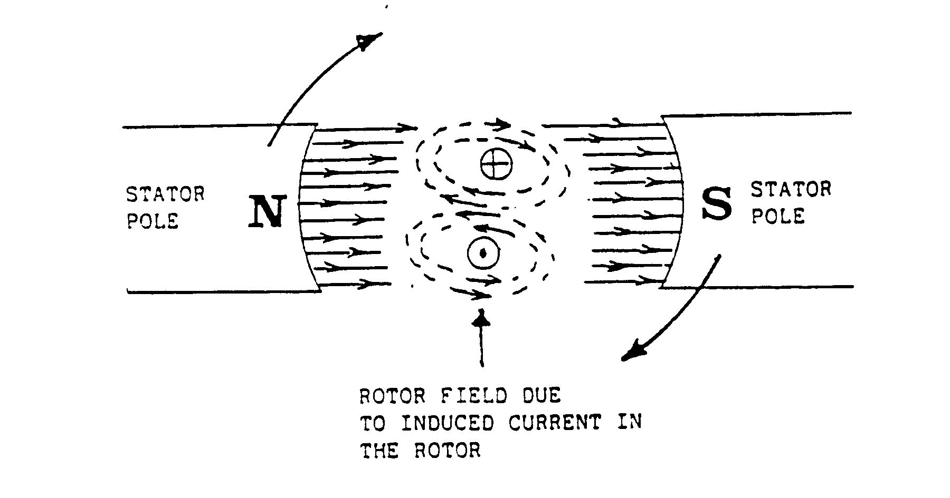Let us look at a simple application of how a field is induced in a rotor.

Remember Len’z Law: any induced current tries to oppose the changing field, which induces it.
We therefore have, in the case of an induction motor, the changing field is the motion of the stator rotating field: so the force exerted on the rotor by the reaction between the rotor and the stator fields will now try to cancel out the continuous motion of the stator field.
That is to say: the rotor will move in the same direction as the stator field, and will try to line up with it. In a practical situation, it gets as close to the moving stator rotating field as its weight and its load will allow.

Motor Slip-Torque Relationship

From the previous explanation it can be seen that it is impossible for the rotor of an induction motor to turn as fast as its rotating magnetic field.

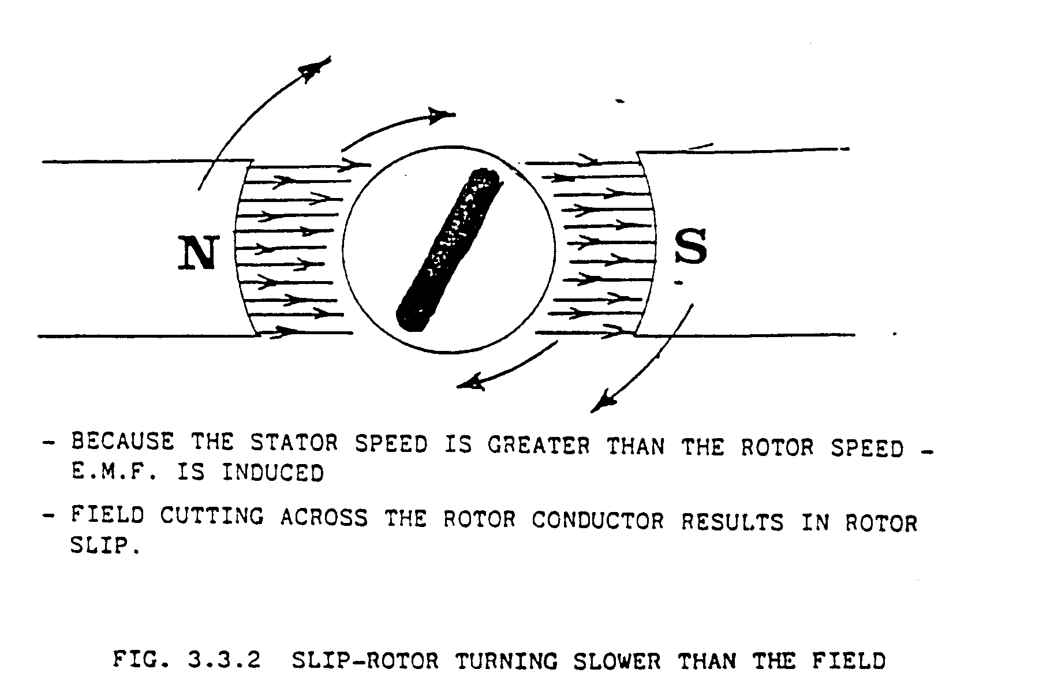Let us look at it this way:
If the speed of the rotor and the rotating magnetic field were the same, then no relative motion would exist between the two; therefore no induced e.o.m. would result in the rotor. We know that, without induced e.o.m. no turning force would be exerted on the rotor. So if relative motion is to exist between the rotor and the rotating magnetic field, the rotor must rotate at a speed lower than that of the rotating magnetic field.
This percentage difference between the speed of the rotor and the speed of the rotating stator field is called “SLIP”.
The smaller the slip, the closer the rotor speed will approach the speed of the rotating stator field.

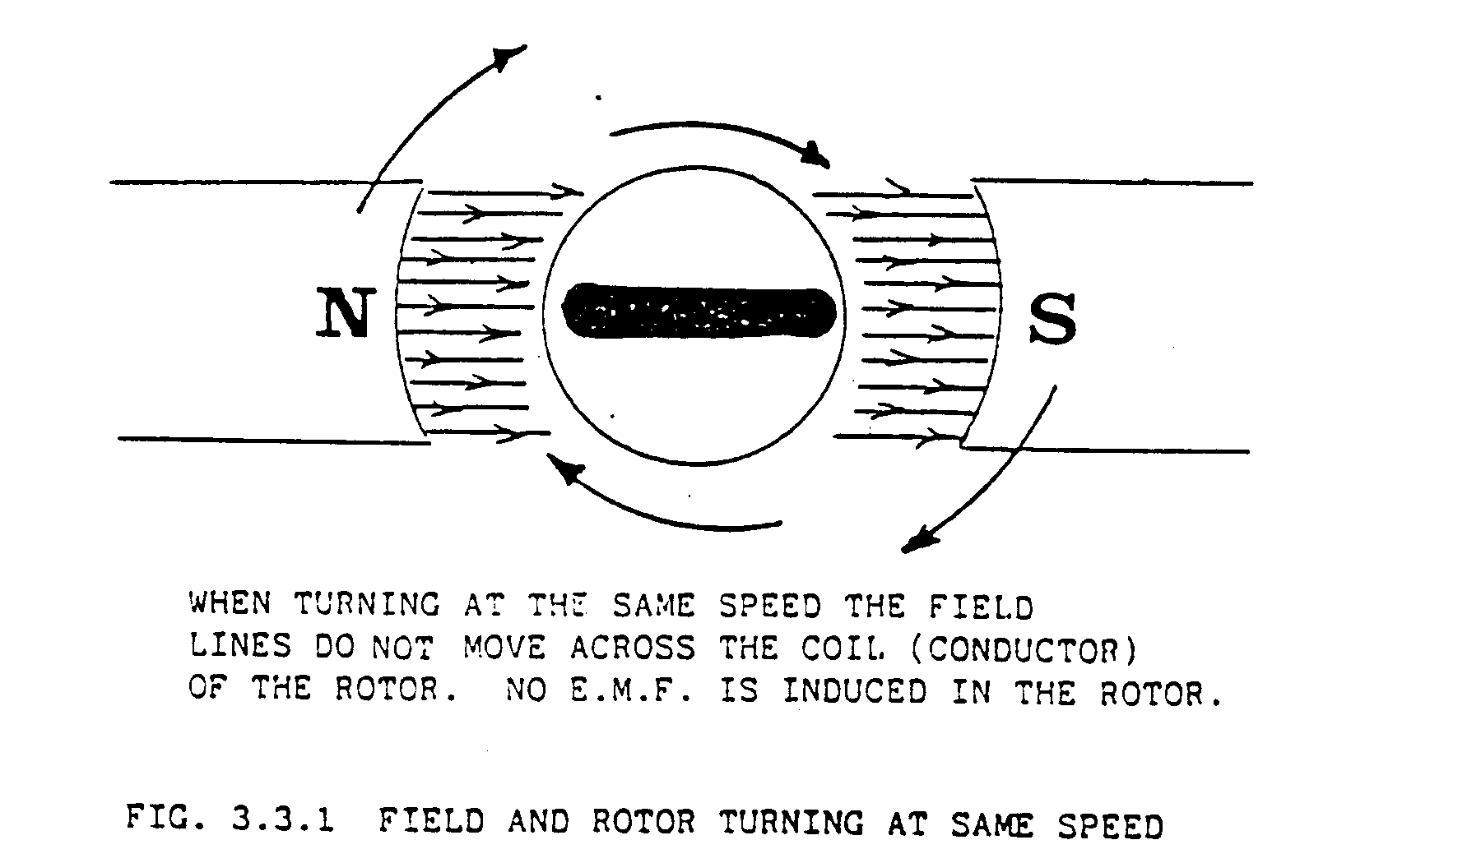Let us look at a simple machine to see what happens.

4 Speed and Torque

The speed of the rotor depends on the torque requirements of the load. The bigger the load, the stronger the turning force needed to rotate the rotor. The turning force can only increase if the emf induced in the rotor increase. For the emf to increase, the magnetic field of the stator must be cut by the rotor at a faster rate.
To accomplish this, the rotor must slow down. Thus if the rotor slows down, a greater e.m.f. Is induced in the rotor, larger currents will flow in the rotor conductors and a greater field interacts with the stator field and a stronger turning force exists.

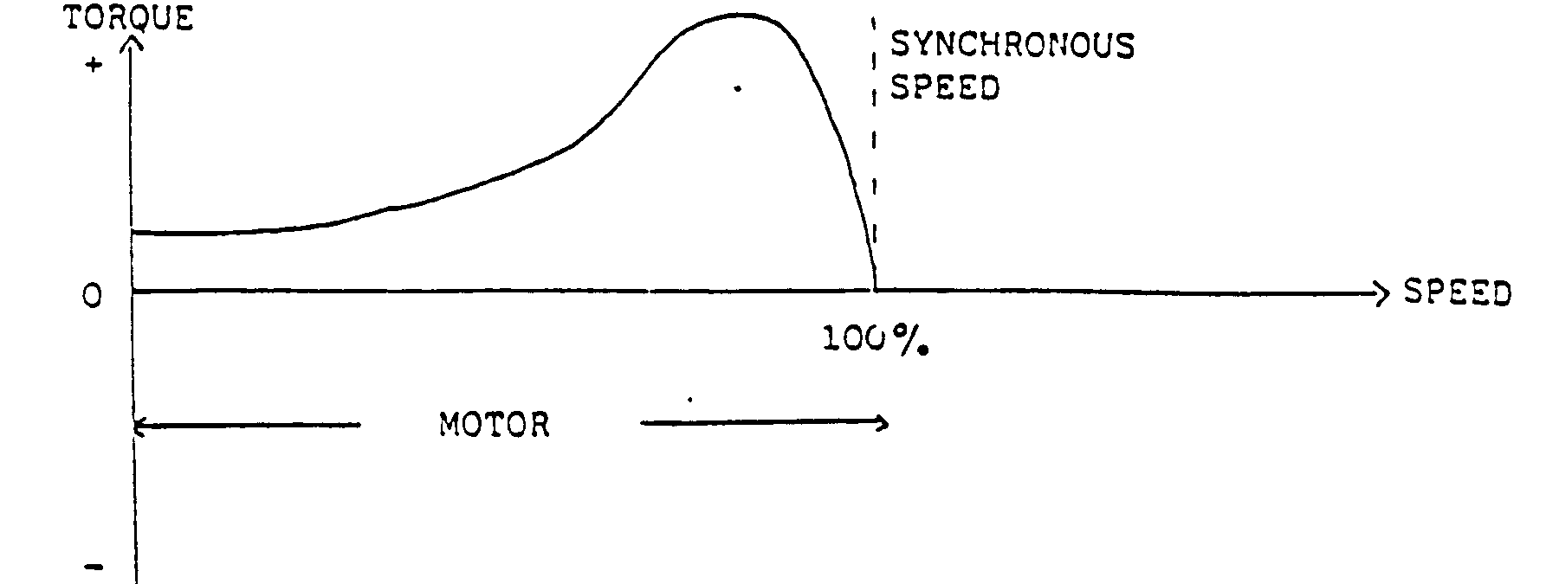Let us now look at a speed - torque curve of an induction motor.

NOTE
There is no torque at synchronous speed.
Motor action is confined to speeds ranging from zero to just below synchronous speed.
(The torque is positive therefore we have motor action).

NOTE
We now have the situation that an induction motor becomes an induction generator when it is being driven above synchronous speed.
In other words, generator action occurs when the motor is driven above synchronous speed, thus we in that the torque is negative and the motor then acts as an A.C. generator.
This generator action can occur on A.C. winders when the weight of the load lowered pulls down and the speed increase above synchronous speed.
If the motor is driven backwards, the speed is negative and the rotor absorbs power, not only from the stator through the air gap but also mechanical powers that is converted into electric power. Thus one way of braking an induction motor or produce decelerating torque, is to reverse the phase sequence of the applied voltage while the motor is running in forward direction.
A method of speed control of an induction motor will follow later in this module.

Stator (Armature field)

The stator construction of the induction motor and the synchronous motor are almost identical and we are not explaining it again.

Rotor Windings

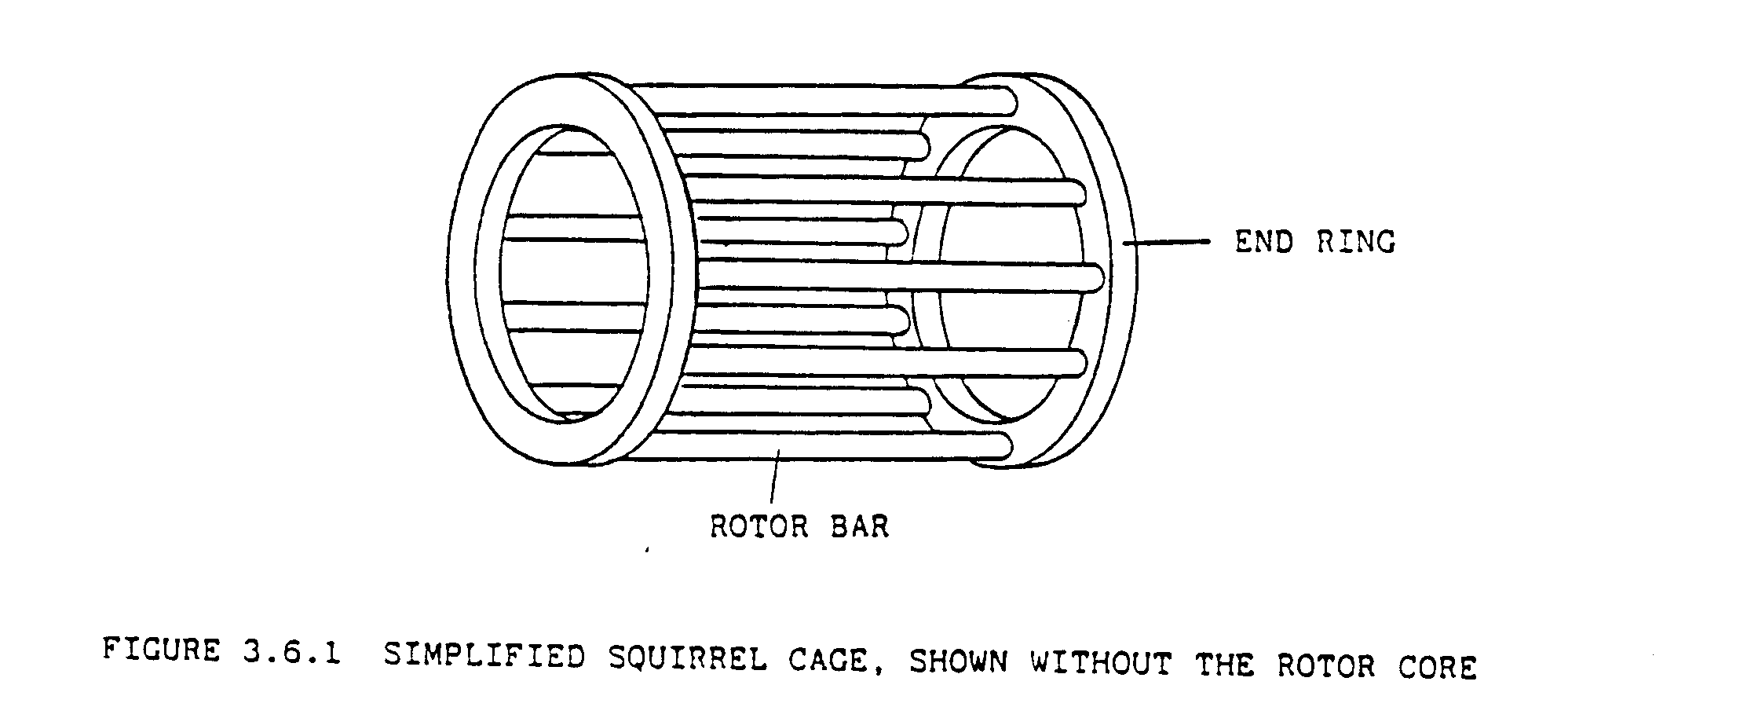The rotor of an induction motor is a laminated cylinder with slots in its surface. The windings in these slots are one of two types. Depending on the type of rotor windings we have a wound-rotor induction motor, also called a slip ring induction motor and a squirrel cage induction motor. (See opposite page for illustration of laminated plates used to build up a stator and rotor core).

Slip Ring Induction Motor

The rotor has its own windings which are three phase windings similar to that in the stator and is wound for the same number of poles as the stator winding. The rotor winding ends in slip rings mounted on the rotor shaft. Brushes ride on these slip rings and during starting or for speed control they are connected externally to equal resistance. More about this at a later stage. The slip ring induction motor is used as a drive motor on an A.C. winder. Another application is on D.C. winders where the slip ring induction motor is used to drive the M.G. set.

Squirrel Cage Induction Motor

The slots in the squirrel cage rotor are occupied by bars of copper or aluminium, known as rotor bars. The rotor bars are short-circuited in two end rings of the same material as the rotor bars. Figure 7.6.1 shows a simplified squirrel cage, only the rotor bars and the end rings are shown without the laminated rotor core. Because very low voltages are generated in the rotor bars, no insulation is required between the core and the bars.

Airgap of the Induction Machine

Because the magnetic field in the rotor is due to the e.m.f induced in the rotor windings by the stator field, the air gap between the stator and rotor are kept very small to obtain maximum field strength. The air gap of induction motors is therefore much smaller than that of the synchronous and D.C. motors, which have, field excitation as well.
The air gap of the induction machine is made as small as the mechanical construction of the motor allows it to be. It ranges from 1,25 mm in small motors to 2,5 mm or more in large motors.
The air gap of the induction motor must also be kept even, because if it is not even, all the windings will not deliver the same maximum torque.

